

BAI211 Artificial Intelligence Fundamentals
First Semester – 2025-2026
Lab Sheet #2

Student ID: _____202411435_____________ Student Name: ______Bibi Ekhkla Hashimi_____________

Basic Introduction to the Prolog Language

Q1. Consider the family tree below:

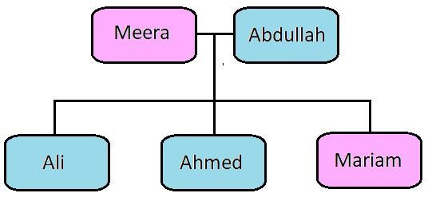

a) Represent the following family tree using male(X), female(X), and parent (X,Y) facts. Then define the following rules: father(X,Y) and mother(X,Y). Test your rules by asking Prolog questions about the family tree.

/* part A */

male(abdullah).
male(ali).
male(ahmed).

female(meera).
female(mariam).

parent(meera,ali).
parent(meera,ahmed).
parent(meera,mariam).

parent(abdullah,ali).
parent(abdullah,ahmed).
parent(abdullah,mariam).

father(X,Y) :- male(X), parent(X,Y).
mother(X,Y) :- female(X), parent(X,Y).

b) Inquire from the system the following:
1. Who is the father of ali? Abdullah
2. Who is the mother of ahmed? Meera
3. Who are the children of meera? Ali , Ahmed and Mariam

Q2. Consider the family tree below:

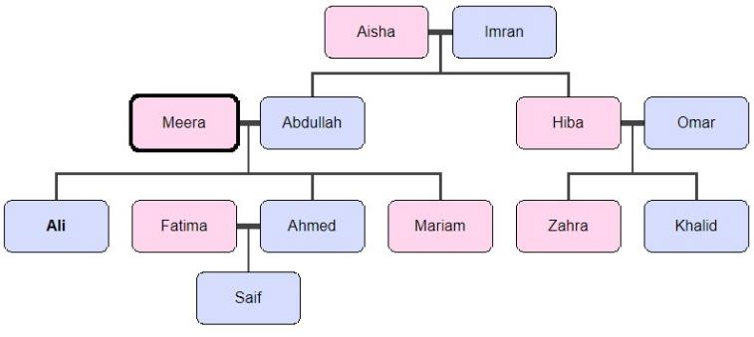

a) Represent the family tree using male(X), female(X), and parent (X,Y) facts. Then define the following rules: father(X,Y), mother (X,Y), brother(X,Y), sister(X,Y), uncle(X,Y), aunt(X,Y), grandFather(X,Y), and grandMother(X,Y), greatGrandFather(X,Y), and greatGrandMother(X,Y).

/* part B */

male(imran).
male(abdullah).
male(omar).
male(ali).
male(ahmed).
male(khalid).
male(saif).

female(aisha).
female(meera).
female(hiba).
female(fatima).
female(mariam).
female(zahra).

parent(aisha,abdullah).
parent(aisha,hiba).

parent(imran,abdullah).
parent(imran,hiba).

parent(meera,ali).
parent(meera,ahmed).
parent(meera,mariam).

parent(abdullah,ali).
parent(abdullah,ahmed).
parent(abdullah,mariam).

parent(hiba,zahra).
parent(hiba,khalid).

parent(omar,zahra).
parent(omar,khalid).

parent(fatima,saif).
parent(ahmed,saif).

father(X,Y) :- male(X), parent(X,Y).
mother(X,Y) :- female(X), parent(X,Y).

brother(X,Y) :- male(X), father(Z,X), father(Z,Y), X\=Y.
sister(X,Y) :- female(X), father(Z,X), father(Z,Y), X\=Y.

uncle(X,Y) :- male(X), brother(X,Z),parent(Z,Y).
uncle(X,Y) :- male(X), sister(X,Z),parent(Z,Y).

aunt(X,Y) :- female(X), sister(X,Z), parent(Z,Y).
aunt(X,Y) :- female(X), brother(X,Z), parent(Z,Y).

grandfather(X,Y) :- male(X),father(X,Z) ,father(Z,Y).
grandfather(X.Y) :- male(X), father(X,Z), mother(Z,Y).

grandmother(X,Y) :- female(X),mother(X,Z), father(Z,Y).
grandmother(X,Y) :- female(X),mother(X,Z),mother(Z,Y).

greatgrandfather(X,Y) :- father(X,Z), grandfather(Z,Y).
greatgrandmother(X,Y) :- mother(X,Z), grandmother(Z,Y).

Test your facts and rules by asking Prolog the following questions:
1. Who are the sisters Ali? Mariam
2. Who is the brother of Zahra? Khalid
3. Who is the uncle of Saif? Ali
4. Who is the aunt of Saif? Mariam
5. Who is the grandmother of Khalid? Aisha
6. Who is the great grandfather of Saif? Imran

